Extra option: AMRAP (As Many Rounds As Possible)

An extra option has to be added called AMRAP. It stands for As many rounds as possible.

Lets say you have to do 4 exercises for 15 minutes in a row. So it could look like this:

**15x push up  
20 x situp  
12x push up  
 10x Burpee**repeat for 15 minutes.

This system is called AMRAP.

I would like to add it to the option of the Workout planner.  
Check my mockup below how that should be done.   
Once an exercise has been selected to AMRAP for a certain set, all exercises in that set must be AMRAP. Total set time is the time of the total set.

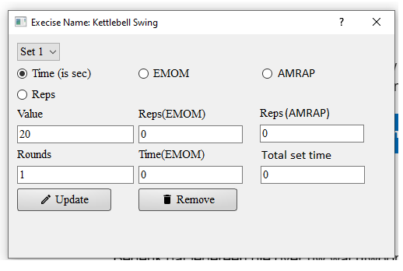

On the printout it should look like this:

Set 1 AMRAP  
  
15x push up  
20 x situp  
12x push up  
10x Burpee  
Repeat for 15 minutes.